NATIONAL

CHILDREN’s

SCIENCE

CONGRESS 2019-20



**JAWAHAR NAVODAYA VIDYALAYA KORLAHALLI, TQ- MUNDARAGI**

**DIST- GADAG-582118**

**NATIONAL CHILDREN’S SCIENCE CONGRESS -2019-20**

**TITLE OF THE PROJCET: HYGIENE IN THE HOTELS OF MUNDARGI**

Students’ Name: **VEENA R MALAGITTI, CLASS: IX**

REVATI S BAVIHALLI, **CLASS: IX**

Guided by: **S H DASAR**

**PGT PHYSICS**

**Inspiration by**

G B MESTRI K SUBHASHINI

Vice Principal Principal

**TITLE: HYGIENE IN THE HOTELS OF MUNDARGI**

**Team members**

Veena R Malagitti, Revati S Bavihalli

**Email:** shdasar72@gmail.com

**ABSTRACT**

**BACKGROUND:** Mundargi is one of the backward taluk. This taluk has many hotels. It has a municipal council. The hotels are not up to the point, because many are not educated. They don’t use good quality food ingredients. They don’t clean the surroundings and the kitchen properly. The food is served in the dirty plates. This survey is essential to bring kind attention of the hotel owners to maintain health and hygiene.

**OBJECTIVES:** 1. To find the cleanliness in the hotels.

2. To identify quality of the food.

3. To know how the food is prepared.

**METHODOLOGY AND WORK PLAN:** It is applied research based on survey. We had made the plan to collect data for analysis. All five team members assigned the responsibility to collect data from decided sample.

**RESULT AND CONCLUSION:** After getting all the data it is classified as per hypothesis of the research and analyzed with the graph. As per data and the sample of the survey it is placed for the graphical presentation. Following result comes for analysis.

* Among 10 hotels 5 hotels maintain cleanliness in good manner 3 hotels maintain cleanliness in moderate manner and 2 hotels maintenance is very poor.
* Among all the hotels 4 hotels don’t have the clean surroundings and the kitchen.
* Only 3 hotels use the clean and good quality ingredients for preparing food items.
* Among all hotels 1 hotel gets water once for 4 days. And 1 hotel gets water thrice for a week. All other hotels have no problem in water supply.
* Among all the hotels 4 hotel labourers use hand wash before and after preparing food and serving.

**CONTENT**

* Introduction
* Aims and objectives
* Methodology
* Results and observations
* Graph no1 –Graph 6
* Interpretation and conclusion
* Solution to the problem and future plan
* References

**TITLE OF THE PROJECT:**

**HYGIENE IN HOTELS OF MUNDARGI**

**AIMS:** Maintenance of health and hygiene in hotels of Mundargi.

**INTRODUCTION:** Food is essential for living organisms’ especially human beings. Hotels are very necessary for providing the food. It has become most earned business. Due to earn more money they are not providing good service. No use of good quality ingredients for preparation of food.

Mundargi is a small town. It is a backward taluk. Like all cities and town it also has hotels .There are very small hotels, medium and large hotels. Daily thousands of people are visiting hotels and having the food.

Our aim is to know the quality and cleanliness and hygiene in the different hotels and the type of effect happens. If the hotels are not maintained properly. So many health issues will come.

**FOOD:**

* Wash the vegetables and fruits before using.
* All exposed foods must be washed with clean water.
* Outer layers, skin of plant material contain thousands of microorganisms and must be washed before use.
* The skin, hair, feathers, intestines of animals contain a number of microbes should be removed before preparation.

**FOOD HANDLING:**

* Food comes into contact with human hands during harvesting, storage, preparation and serving.
* Food handlers should be free from any communicable diseases.
* Human hair, nasal discharge, skin can also be source of microorganisms.

* Parts of blenders, mixers should be inspected after cleaning to ensure that there is no food material remaining.
* Clean and sanitize equipments work surfaces and utensils after preparing each foods
* Use specific containers for various food products

**PREVENTIVE MEASURES TO STOP THE ENTRY OF INSECTS:**

* Keeping the prepared food in cupboards with wire-netting
* Filling cracks, fissures in the walls and flooring.
* Covering drains, holes with wire gauze.
* Spraying or dusting with a pesticide in home.

**FOOD CONTAMINATION**

Foods may be contaminated if the

**HYPOTHESIS:**

* The surroundings and the kitchen of some hotels are not clean.
* The quality of the food ingredients is not good.
* The workers in the hotel don’t use the hand wash before and after cooking.
* They use the Napkins and gloves while cooking.
* The plate in which the food is served is not cleaned properly.

**NEED STATEMENT AND RELEVANCE**

This is 21st century world which is rapidly changing. This is the century in which the cleanliness has more importance. Every living thing needs food. But man is using his power towards the bad things. Man has become very greedy he thinks only about his profit. So he starts to use the ingredients of low cost.

Mundargi is the taluk in Karnataka state and Gadag district which there are many hotels as we know food is very essential for all human beings all of us mainly go to the hotels. We have come to know that the Hotels of Mundargi are not clean and the people of the town are not aware of that. The ingredients are not of much quality. So it was very

necessary to conduct the survey to create awareness about the maintenance of the hotels.

**OBJECTIVES:**

* To know about the health and hygiene in the hotels of Mundargi.
* To identify the quality of food served in the hotels of Mundargi.
* To know about the cleanliness of the plates and vessels in which the food is served or cooked in the hotels of Mundargi.
* To know about the cleanliness of water which is used to drink or cook food in the hotels of Mundargi.
* To give some suggestions to use the essential things in preparation of food.

**METHODOLOGY**

It is applied research based on survey. We had made the plan to collect data for analysis. All five team members assigned the responsibility to collect data from decided sample. Students prepared response sheet to collect data which had mentioned name of the hotels as (A, B….) asking questions about the cleanliness of the hotel and the information about the food ingredients. As per information given by the hotel owner’s response sheet is filled by students. The survey of Mundargi had been done by with the students. Students made the data sheet for getting the response for the data analysis. The survey had been completed as per the time scheduled and convenience of the owners and works of the hotels of Mundargi. And received the data analyzed with statistical tools.

**DATA ANALYSIS**

All the data was systematically recorded in the Microsoft word and later on the data was converted into the bar charts for pictorial representation of the results.

Hypotheses no. 1

* The surroundings and the kitchen of some hotels are not clean.

Objective no.1 to find maintenance health and hygiene in the hotel of Mundargi.

Graph no.1

Graph no.2

Objective no. 2 To know the water used in the hotels.

Graph no. 3

Graph no.4

a)

b)

As per graph no 1, 2, 3 and 4(a, b) it is found that there are only 5 good hotels in Mundargi and the 2are in very bad condition. And 3 are in moderate condition. In overall 100% only

50% of hotels are maintaining good health and hygiene in the hot of Mundargi. The food prepared in the hotels is prepared by using the rain water, river water and the R O water.

The percentage of using river water is 50% for cooking & 30% for drinking. The rain water used for drinking is 20% and for cooking is 20%. The R O water used for drinking is 50% and for cooking food is 30%.

Hypotheses no. 2

Hand wash is not used properly.

Objective no. 1

To know about that how many hotel workers use hand wash before and after cooking

Graph no. 5

As per graph no.5 it is found that only 40% of the hotel workers use hand wash before and after cooking food. It means among 10 hotels only 4 hotel workers use hand wash.

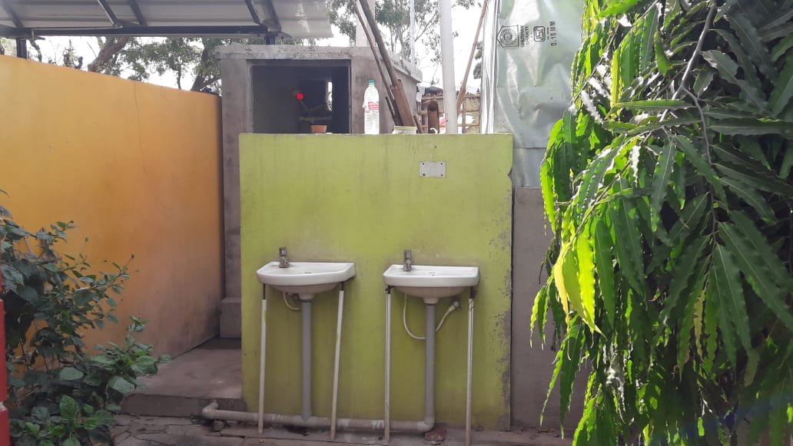 **PHOTOS OF DATA COLLECTION**

 **PHOTOS OF DATA COLLECTION**

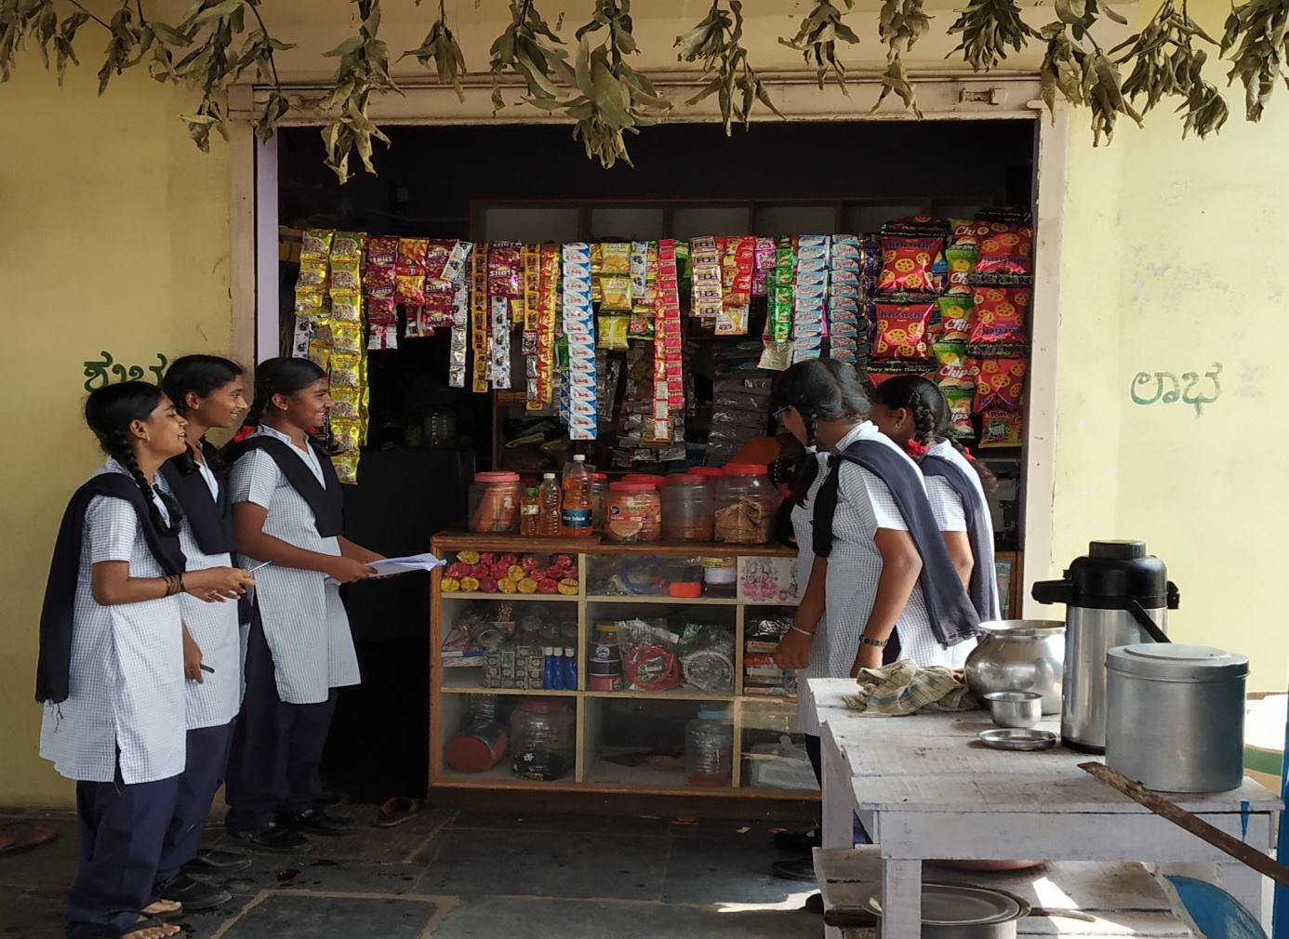

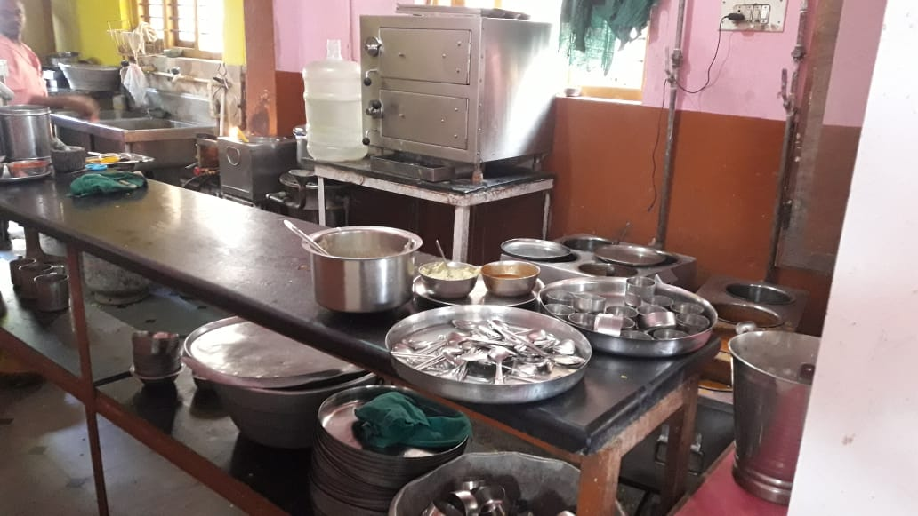

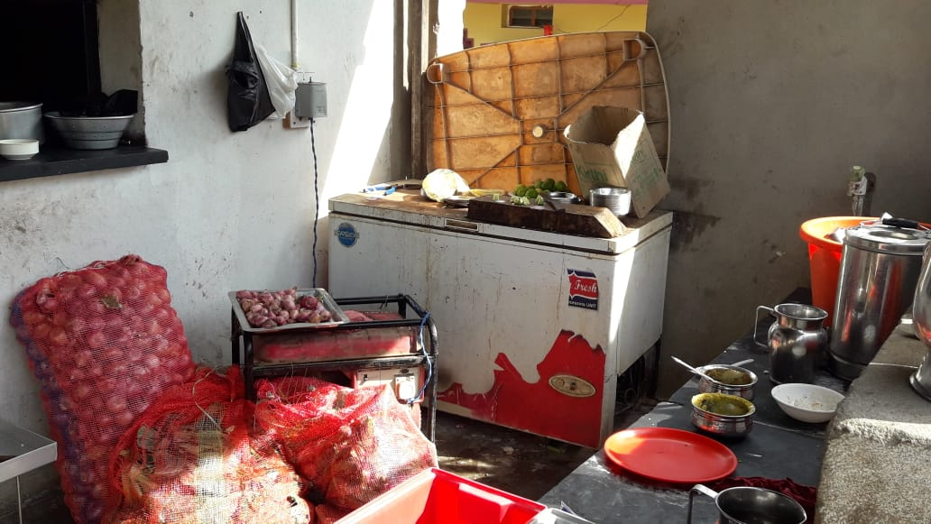

* They don’t use hand wash before and after cleaning or preparing food.
* They don’t use gloves and some clothes while preparing food.

**Solutions to the problem:**

* Using good quality ingredients in preparation of food.
* Using hand wash before and after using food.
* Using detergent and soap to clean plates.
* Using acid and detergent powder to clean the floor and the kitchen area of the hotels.
* Using purified water in preparation of food.

**Future plan**

* + - * Creating awareness about building a hotel where there is good facility of water.
      * Suggesting the hotel owners and the worker to use hand wash and napkins.
      * Suggesting them to clean plates and vessels with soap and detergent cake.
      * Creating awareness about using good quality ingredients in preparation of food.
      * Suggesting them to clean and maintain hygiene in the hotels. And use antiseptic liquids and acids in cleaning the floor.

**ACKNOWLEDGEMENT**

I deeply express our gratitude to our honorable Principal

K. Subhashini and Vice Principal G, B, Mestri, Whose guidance, support and direction to bringing up this project is of a great help.

I wholeheartedly thank our guide S. H. Dasar (PGT Physics) for his encouragement and guidance given to me.

I also thank my team members whose co-operation is immense help in preparing this project.

Group leader: Veena R Malagitti Class: IX

Group members:

Vidya K Helavi Class: IX

Rakshita B Talawar Class: IX

Swati M Nagavi Class: IX

Rakshita H Halemani Class: IX

S H Dasar G B Mestri K.Subhashini

Guide teacher Vice Principal Principal

**Future plan**

* + - * Creating awareness about building a hotel where there is good facility of water.
      * Suggesting the hotel owners and the worker to use hand wash and napkins.
      * Suggesting them to clean plates and vessels with soap and detergent cake.
      * Creating awareness about using good quality ingredients in preparation of food.
      * Suggesting them to clean and maintain hygiene in the hotels. And use antiseptic liquids and acids in cleaning the floor.

**ACKNOWLEDGEMENT**

I deeply express our gratitude to our honorable Principal

K. Subhashini and Vice Principal G, B, Mestri, Whose guidance, support and direction to bringing up this project is of a great help.

I wholeheartedly thank our guide S. H. Dasar (PGT Physics) for his encouragement and guidance given to me.

I also thank my team members whose co-operation is immense help in preparing this project.

Group leader: Veena R Malagitti Class: IX

Group members:

Vidya K Helavi Class: IX

Rakshita B Talawar Class: IX

Swati M Nagavi Class: IX

Rakshita H Halemani Class: IX

S H Dasar G B Mestri K.Subhashini

Guide teacher Vice Principal Principal

**Reference:**

* **www. Wikipedia. com**
* **Daily newspapers**
* **Science reporters**
* **NCERT Books 7th, 8th and 9th**